
Министерство науки и высшего образования Российской Федерации Федеральное государственное бюджетное образовательное учреждение высшего образования
«Московский государственный технический университет имени Н.Э. Баумана
(национальный исследовательский университет)»
(МГТУ им. Н.Э. Баумана)

Факультет «Информатика и системы управления»
Кафедра ИУ5 «Системы обработки информации и управления»

Курс «Методы машинного обучения»

Отчет по лабораторной работе 3

Выполнил:
студент группы ИУ5-22М Зоров В..В
20.05.2023

Москва, 2023 г.
Лабораторная работа 3. Выполнил Зоров Владислав Витальевич ИУ5-22м
Задание: Выбрать один или несколько наборов данных (датасетов) для решения следующих задач. Каждая задача может быть решена на отдельном датасете, или несколько задач могут быть решены на одном датасете. Просьба не использовать датасет, на котором данная задача решалась в лекции. Для выбранного датасета (датасетов) на основе материалов лекций решить следующие задачи: масштабирование признаков (не менее чем тремя способами); обработку выбросов для числовых признаков (по одному способу для удаления выбросов и для замены выбросов); обработку по крайней мере одного нестандартного признака (который не является числовым или категориальным); отбор признаков: один метод из группы методов фильтрации (filter methods); один метод из группы методов обертывания (wrapper methods); один метод из группы методов вложений (embedded methods).
In [2]:
# !pip install scikit-learn import numpy as np import pandas as pd import seaborn as sns
import matplotlib.pyplot as plt
%matplotlib inline sns.set(style="ticks")
from sklearn.impute import SimpleImputer from sklearn.impute import MissingIndicator import scipy.stats as stats
from sklearn.model_selection import train_test_split from sklearn.preprocessing import StandardScaler from sklearn.preprocessing import MinMaxScaler from sklearn.preprocessing import RobustScaler from sklearn.linear_model import LogisticRegression from sklearn.svm import LinearSVC
Defaulting to user installation because normal site-packages is not writeable
Collecting scikit-learn
Downloading scikit_learn-1.2.2-cp310-cp310-manylinux_2_17_x86_64.manylinux2014_x86_64.wh l (9.6 MB)
━━━━━━━━━━━━━━━━━━━━━━━━━━━━━━━━━━━━━━━━ 9.6/9.6 MB 174.2 kB/s eta 0:00:00m eta 0:00:01[36m0:00:02
Requirement already satisfied: joblib>=1.1.1 in /home/user/.local/lib/python3.10/site-pack
ages (from scikit-learn) (1.2.0)
Requirement already satisfied: numpy>=1.17.3 in /usr/lib/python3/dist-packages (from sciki t-learn) (1.21.5)
Collecting threadpoolctl>=2.0.0
Downloading threadpoolctl-3.1.0-py3-none-any.whl (14 kB)
Requirement already satisfied: scipy>=1.3.2 in /usr/lib/python3/dist-packages (from scikit -learn) (1.8.0)
Installing collected packages: threadpoolctl, scikit-learn
Successfully installed scikit-learn-1.2.2 threadpoolctl-3.1.0
Id
MSSubClass
MSZoning
LotFrontage
LotArea
Street
Alley
LotShape
LandContour
Utilities
...
PoolArea
0
1
60
RL
65.0
8450
Pave
NaN
Reg
Lvl
AllPub
...
0
1
2
20
RL
80.0
9600
Pave
NaN
Reg
Lvl
AllPub
...
0
In [2]:
data

=

pd
.
read_csv
(
"data.csv"
)

In [3]:
data
.
head
()

Out[3]:
Id MSSubClass MSZoning LotFrontage LotArea Street Alley LotShape LandContour Utilities ... PoolArea
In [4]:
Out[4]: Po
- 3 60  - 4 70  - 5 60  - rows × 81 columns |  |  | RL  RL  RL |  | 68.0 11250 Pave NaN  60.0 9550 Pave NaN  84.0 14260 Pave NaN |  |  |  |  |  |  |  |  | IR1  IR1  IR1 |  |  | Lvl AllPub ... 0  Lvl AllPub ... 0  Lvl AllPub ... 0
 | data = data.drop('Id', 1) data.head()
<ipython-input-4-c100a8de87ec>:1: FutureWarning: In a future version ts of DataFrame.drop except for the argument 'labels' will be keyword-only. data = data.drop('Id', 1)  MSSubClass MSZoning LotFrontage LotArea Street Alley LotShape LandContour Utilities |  |  |  |  |  |  |  |  |  |  |  |  |  |  |  |  |  |  |  | of pandas all argumen  LotConfig |  | ...
- 60  - 20  - 60  - 70  - 60  - rows × 80 columns |  | RL  RL  RL  RL  RL |  | 65.0  80.0  68.0  60.0  84.0 |  | 8450  9600  11250  9550  14260 |  | Pave  Pave  Pave  Pave  Pave |  | NaN  NaN  NaN  NaN  NaN |  | Reg  Reg  IR1  IR1  IR1 |  |  | Lvl  Lvl  Lvl  Lvl  Lvl |  |  | AllPub  AllPub  AllPub  AllPub  AllPub |  |  | Inside  FR2  Inside  Corner FR2 | ...  ...  ...  ...  ...
 | # Удаление колонок с высоким процентом пропусков (более 25%) data.dropna(axis=1, thresh=1095)
 | MSSubClass MSZoning LotFrontage |  |  |  |  |  | LotArea |  | Street |  | LotShape |  | LandContour |  |  | Utilities |  |  | LotConfig |  |  | LandSlope
- 60  - 20  - 60  - 70  - 60  ... ... 1455 60  - 20  - 70  - 20  - 20  - rows × 75 columns |  |  | RL  RL  RL  RL  RL  ...  RL  RL  RL  RL  RL |  | 65.0  80.0  68.0  60.0  84.0  ...  62.0  85.0  66.0  68.0  75.0 |  | 8450  9600  11250  9550  14260  ...  7917  13175  9042  9717  9937 |  | Pave  Pave  Pave  Pave  Pave  ...  Pave  Pave  Pave  Pave  Pave |  | Reg  Reg  IR1  IR1  IR1  ...  Reg  Reg  Reg  Reg  Reg |  | Lvl  Lvl  Lvl  Lvl  Lvl  ...  Lvl  Lvl  Lvl  Lvl  Lvl |  |  | AllPub  AllPub  AllPub  AllPub  AllPub  ...  AllPub  AllPub  AllPub  AllPub  AllPub |  |  | Inside  FR2  Inside  Corner  FR2  ...  Inside  Inside  Inside  Inside  Inside |  |  | .
 | # Заполним пропуски средними значениями def impute_na(df, variable, value):
In [5]:
Out[5]:
Gt
Gt
Gt
Gt
Gt
Gt
Gt
Gt
Gt
Gt
In [6]:
std | 42.300571 | 22.024023 | 9981.264932 | 1.382997 | 1.112799 | 30.202904 | 20.645407 | 181.06620
min | 20.000000 | 21.000000 | 1300.000000 | 1.000000 | 1.000000 | 1872.000000 | 1950.000000 | 0.00000
25% | 20.000000 | 60.000000 | 7553.500000 | 5.000000 | 5.000000 | 1954.000000 | 1967.000000 | 0.00000
50% | 50.000000 | 70.049958 | 9478.500000 | 6.000000 | 5.000000 | 1973.000000 | 1994.000000 | 0.00000
75% | 70.000000 | 79.000000 | 11601.500000 | 7.000000 | 6.000000 | 2000.000000 | 2004.000000 | 166.00000
max | 190.000000 | 313.000000 | 215245.000000 | 10.000000 | 9.000000 | 2010.000000 | 2010.000000 | 1600.00000
8 rows × 37 columns
In [8]:
def obj_col(column): return column[1] == 'object'

col_names = [] for col in list(filter(obj_col, list(zip(list(data.columns), list(data.dtypes))))):
col_names.append(col[0]) col_names.append('SalePrice')
In [9]:
X_ALL

=

data
.
drop
(
col_names
,

axis
=
1
)

# Обучаем StandardScaler на всей выборке и масштабируем cs11 = StandardScaler()
In [10]:
MSSubClass
LotFrontage
LotArea
OverallQual
OverallCond
YearBuilt
YearRemodAdd
MasVnrAr
e
count
1460.000000
1460.000000
1460.000000
1460.000000
1460.000000
1460.000000
1460.000000
1452.00000
mean
56.897260
70.049958
10516.828082
6.099315
5.575342
1971.267808
1984.865753
103.68526

df
[
variable
]
.
fillna
(
value
,

inplace
=
True
)

impute_na
(
data
,

'LotFrontage'
,

data
[
'LotFrontage'
]
.
mean
())

In [7]:
data
.
describe
()

Out[7]:
# Функция для восстановления датафрейма
# на основе масштабированных данных def arr_to_df(arr_scaled): res = pd.DataFrame(arr_scaled, columns=X_ALL.columns)
return res
In [11]:
# Разделим выборку на обучающую и тестовую
X_train, X_test, y_train, y_test = train_test_split(X_ALL, data['SalePrice'], test_size=0.2, random_state=1)
# Преобразуем массивы в DataFrame
X_train_df = arr_to_df(X_train)
X_test_df = arr_to_df(X_test)

X_train_df.shape, X_test_df.shape
((1168, 36), (292, 36)) Out[11]:

StandardScaler
In [12]:
Out[12]: MSSubClass LotFrontage LotArea OverallQual OverallCond YearBuilt YearRemodAdd MasVnrArea Bsmt

0 0.073375 -0.229372 -0.207142 0.651479 -0.517200 1.050994 0.878668 0.510015 0.5 1 -0.872563 0.451936 -0.091886 -0.071836 2.179628 0.156734 -0.429577 -0.572835 1.1
- 0.073375 -0.093110 0.073480 0.651479 -0.517200 0.984752 0.830215 0.322174 0.0
- 0.309859 -0.456474 -0.096897 0.651479 -0.517200 -1.863632 -0.720298 -0.572835 -0.4 4 0.073375 0.633618 0.375148 1.374795 -0.517200 0.951632 0.733308 1.360826 0.4
... ... ... ... ... ... ... ... ...
1455 0.073375 -0.365633 -0.260560 -0.071836 -0.517200 0.918511 0.733308 -0.572835 -0.9 1456 -0.872563 0.679039 0.266407 -0.071836 0.381743 0.222975 0.151865 0.084610 0.7 1457 0.309859 -0.183951 -0.147810 0.651479 3.078570 -1.002492 1.024029 -0.572835 -0.3
1458 -0.872563 -0.093110 -0.080160 -0.795151 0.381743 -0.704406 0.539493 -0.572835 -0.8 1459 -0.872563 0.224833 -0.058112 -0.795151 0.381743 -0.207594 -0.962566 -0.572835 0.8
data_cs11_scaled_temp = cs11.fit_transform(X_ALL)
# формируем DataFrame на основе массива
data_cs11_scaled = arr_to_df(data_cs11_scaled_temp) data_cs11_scaled
1460 rows × 36 columns
In [13]:
# Построение плотности распределения def draw_kde(col_list, df1, df2, label1, label2): fig, (ax1, ax2) = plt.subplots( ncols=2, figsize=(12, 5))
# первый график ax1.set_title(label1)
sns.kdeplot(data=df1[col_list], ax=ax1)
# второй график ax2.set_title(label2)
sns.kdeplot(data=df2[col_list], ax=ax2) plt.show()
In [14]:_{о}
draw_kde(['LotFrontage', 'LotArea', 'OverallCond'], data, data_cs11_scaled, 'До масштабир

Масштабирование "Mean Normalisation"
In [15]:
# Разделим выборку на обучающую и тестовую
X_train, X_test, y_train, y_test = train_test_split(X_ALL, data['SalePrice'], test_size=0.2, random_state=1)
# Преобразуем массивы в DataFrame
X_train_df = arr_to_df(X_train)
X_test_df = arr_to_df(X_test)

X_train_df.shape, X_test_df.shape
((1168, 36), (292, 36)) Out[15]:
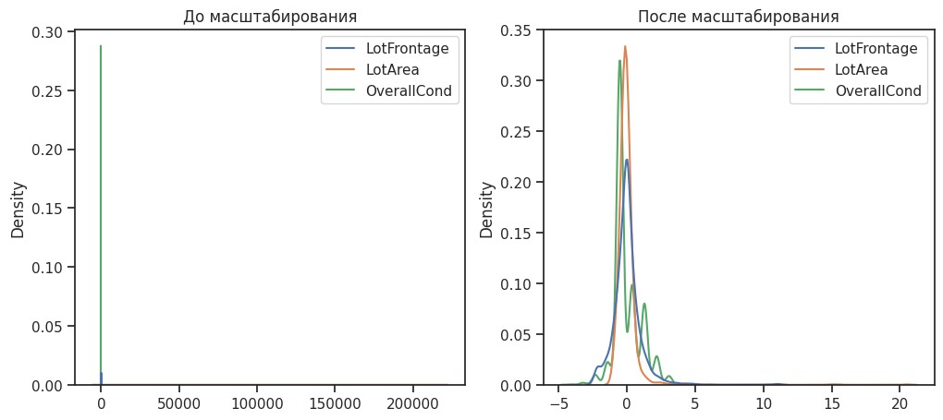
In [16]:
class MeanNormalisation:
def fit(self, param_df): self.means = X_train.mean(axis=0) maxs = X_train.max(axis=0) mins = X_train.min(axis=0) self.ranges = maxs - mins
def transform(self, param_df): param_df_scaled = (param_df - self.means) / self.ranges return param_df_scaled
def fit_transform(self, param_df): self.fit(param_df)
return self.transform(param_df)
In [17]:
sc21 = MeanNormalisation()
data_cs21_scaled = sc21.fit_transform(X_ALL) data_cs21_scaled.describe()
Out[17]: MSSubClass LotFrontage LotArea OverallQual OverallCond YearBuilt YearRemodAdd MasVnrArea

count 1460.000000 1460.000000 1460.000000 1460.000000 1460.000000 1460.000000 1460.000000 1452.000000 mean 0.000962 -0.000452 -0.000119 -0.003900 -0.003058 -0.003544 -0.008644 -0.000898 MSSubClass LotFrontage LotArea OverallQual OverallCond YearBuilt YearRemodAdd MasVnrArea

std | 0.248827 | 0.075425 | 0.046653 | 0.153666 | 0.158971 | 0.218862 | 0.344090 | 0.113166
min | -0.216081 | -0.168431 | -0.043200 | -0.570491 | -0.656678 | -0.722876 | -0.589740 | -0.065702
25% | -0.216081 | -0.034869 | -0.013970 | -0.126046 | -0.085250 | -0.128673 | -0.306407 | -0.065702
50% | -0.039610 | -0.000452 | -0.004973 | -0.014935 | -0.085250 | 0.009008 | 0.143593 | -0.065702
75% | 0.078037 | 0.030199 | 0.004951 | 0.096176 | 0.057608 | 0.204661 | 0.310260 | 0.038048
max | 0.783919 | 0.831569 | 0.956800 | 0.429509 | 0.486179 | 0.277124 | 0.410260 | 0.934298
8 rows × 36 columns
In [18]:
cs22 = MeanNormalisation() cs22.fit(X_train)
data_cs22_scaled_train = cs22.transform(X_train) data_cs22_scaled_test = cs22.transform(X_test)
LotFrontage LotArea
MSSubClass
OverallQual
OverallCond
YearBuilt
YearRemodAdd
MasV
1.168000e+03
1.168000e+03
1.168000e+03
1.168000e+03
1.168000e+03
1.168000e+03
1.1600
1.392531e-17
-1.140640e-
18
2.718526e-17
9.125121e-18
7.224054e-16
-1.502508e-15
-2.5
In [19]:
data_cs22_scaled_train
.
describe
()

Out[19]:
count 1.168000e+03
-1.672939emean
17
std | 2.475340e-01 | 7.707084e-02 | 4.616115e-02 | 1.522067e-01 | 1.587482e-01 | 2.195064e-01 | 3.431316e-01 | 1.112
min | -2.160808e01 | -1.684311e01 | -4.319969e02 | -5.704909e01 | -5.138209e01 | -7.228757e01 | -5.897403e-01 | -6.5
25% | -2.160808e01 | -3.486947e02 | -1.422028e02 | -1.260464e01 | -8.524951e02 | -1.286728e01 | -2.897403e-01 | -6.5
50% | -3.961019e02 | -4.518024e04 | -4.865072e03 | -1.493531e02 | -8.524951e02 | 1.625472e-02 | 1.435930e-01 | -6.5
75% | 7.803687e-02 | 3.019903e-02 | 5.045185e-03 | 9.617580e-02 | 5.760763e-02 | 2.119069e-01 | 3.102597e-01 | 4.070
max | 7.839192e-01 | 8.315689e-01 | 9.568003e-01 | 4.295091e-01 | 4.861791e-01 | 2.771243e-01 | 4.102597e-01 | 9.342
8 rows × 36 columns
draw_kde(['LotFrontage', 'LotArea', 'OverallCond'], data, data_cs21_scaled, 'До масштабир
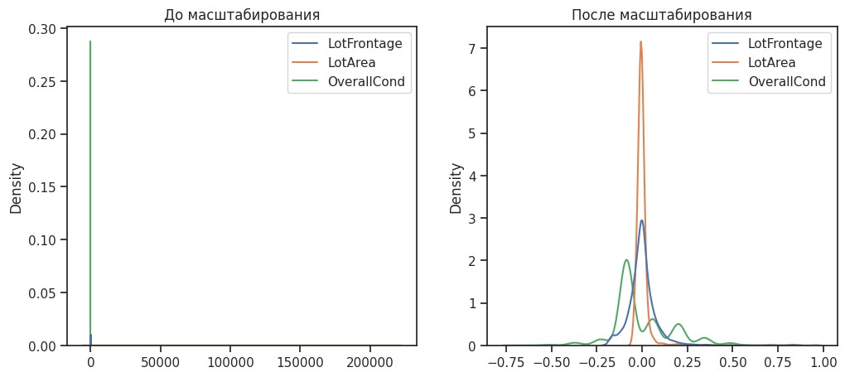
In [20]:_{о} In [21]:_{l}
draw_kde(['LotFrontage', 'LotArea', 'OverallCond'], data_cs22_scaled_train, data_cs22_sca
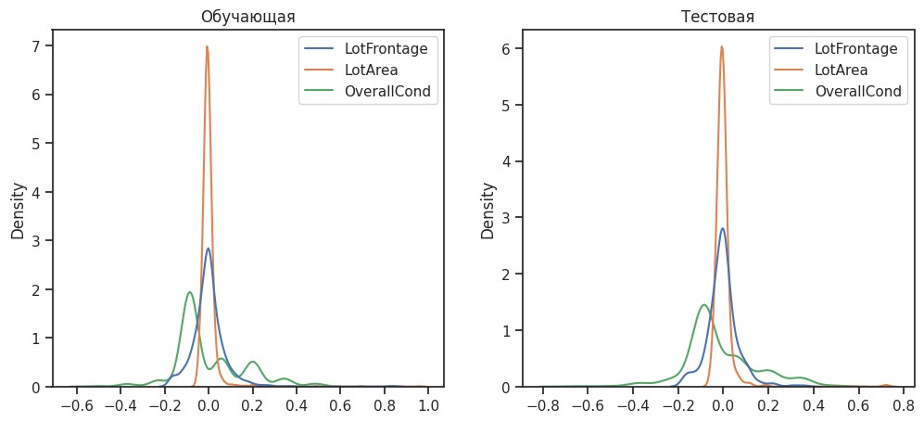

MinMax-масштабирование
In [22]:
# Обучаем StandardScaler на всей выборке и масштабируем cs31 = MinMaxScaler()
data_cs31_scaled_temp = cs31.fit_transform(X_ALL)
# формируем DataFrame на основе массива
data_cs31_scaled = arr_to_df(data_cs31_scaled_temp)
data_cs31_scaled.describe()
Out[22]: MSSubClass LotFrontage LotArea OverallQual OverallCond YearBuilt YearRemodAdd MasVnrArea

count | 1460.000000 | 1460.000000 | 1460.000000 | 1460.000000 | 1460.000000 | 1460.000000 | 1460.000000 | 1452.000000
mean | 0.217043 | 0.167979 | 0.043080 | 0.566591 | 0.571918 | 0.719332 | 0.581096 | 0.064803
std | 0.248827 | 0.075425 | 0.046653 | 0.153666 | 0.139100 | 0.218862 | 0.344090 | 0.113166
min | 0.000000 | 0.000000 | 0.000000 | 0.000000 | 0.000000 | 0.000000 | 0.000000 | 0.000000
MSSubClass LotFrontage LotArea OverallQual OverallCond YearBuilt YearRemodAdd MasVnrArea

25% | 0.000000 | 0.133562 | 0.029229 | 0.444444 | 0.500000 | 0.594203 | 0.283333 | 0.000000
50% | 0.176471 | 0.167979 | 0.038227 | 0.555556 | 0.500000 | 0.731884 | 0.733333 | 0.000000
75% | 0.294118 | 0.198630 | 0.048150 | 0.666667 | 0.625000 | 0.927536 | 0.900000 | 0.103750
max | 1.000000 | 1.000000 | 1.000000 | 1.000000 | 1.000000 | 1.000000 | 1.000000 | 1.000000
8 rows × 36 columns
In [23]:
cs32 = MinMaxScaler() cs32.fit(X_train)
data_cs32_scaled_train_temp = cs32.transform(X_train) data_cs32_scaled_test_temp = cs32.transform(X_test)
# формируем DataFrame на основе массива
data_cs32_scaled_train = arr_to_df(data_cs32_scaled_train_temp) data_cs32_scaled_test = arr_to_df(data_cs32_scaled_test_temp)
In [24]:_{о}
draw_kde(['LotFrontage', 'LotArea', 'OverallCond'], data, data_cs31_scaled, 'До масштабир
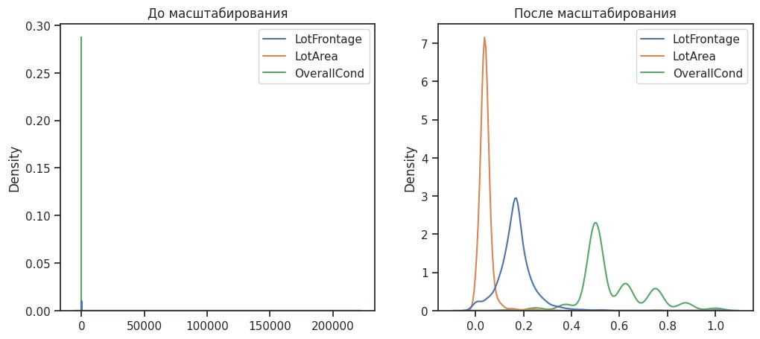
In [25]:_{l}
draw_kde(['LotFrontage', 'LotArea', 'OverallCond'], data_cs32_scaled_train, data_cs32_sca

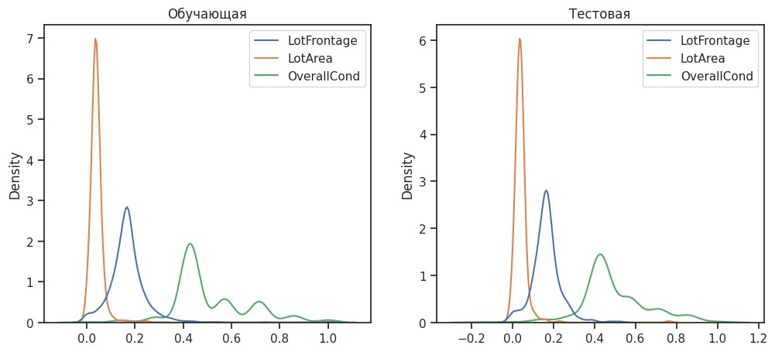
Обработка выбросов для числовых признаков
def

diagnostic_plots
(
df
,

variable
,

title
):

Manufacturer
Model
Sales_in_thousands
__year_resale_value
Vehicle_type
Price_in_thousands
Engine_size
Hors
0
Acura
Integra
16.919
16.360
Passenger
21.50
1.8
In [26]:
data2

=

pd
.
read_csv
(
"Car_sales.csv"
)

In [27]:
data2
.
head
()

Out[27]:
1 | Acura | TL | 39.384 | 19.875 | Passenger | 28.40 | 3.2
2 | Acura | CL | 14.114 | 18.225 | Passenger | NaN | 3.2
3 | Acura | RL | 8.588 | 29.725 | Passenger | 42.00 | 3.5
4 | Audi | A4 | 20.397 | 22.255 | Passenger | 23.99 | 1.8
Sales_in_thousands
__year_resale_value
Price_in_thousands
Engine_size
Horsepower
Wheelbase
Width
count
157.000000
121.000000
155.000000
156.000000
156.000000
156.000000
156.000000
mean
52.998076
18.072975
27.390755
3.060897
185.948718
107.487179
71.150000
In [28]:
data2
.
describ
e
()

Out[28]:
std | 68.029422 | 11.453384 | 14.351653 | 1.044653 | 56.700321 | 7.641303 | 3.451872
min | 0.110000 | 5.160000 | 9.235000 | 1.000000 | 55.000000 | 92.600000 | 62.600000
25% | 14.114000 | 11.260000 | 18.017500 | 2.300000 | 149.500000 | 103.000000 | 68.400000
50% | 29.450000 | 14.180000 | 22.799000 | 3.000000 | 177.500000 | 107.000000 | 70.550000
75% | 67.956000 | 19.875000 | 31.947500 | 3.575000 | 215.000000 | 112.200000 | 73.425000
max | 540.561000 | 67.550000 | 85.500000 | 8.000000 | 450.000000 | 138.700000 | 79.900000
In [29]:
In [30]:
diagnostic_plots
(
data2
,

'Sales_in_thousands'
,

'Sales_in_thousands - original'
)

<ipython-input-29-1fe78d5d2ee2>:4: MatplotlibDeprecationWarning: Auto-removal of overlappi ng axes is deprecated since 3.6 and will be removed two minor releases later; explicitly c all ax.remove() as needed. plt.subplot(2, 2, 1)
fig, ax = plt.subplots(figsize=(10,7))
# гистограмма plt.subplot(2, 2, 1) df[variable].hist(bins=30)
## Q-Q plot plt.subplot(2, 2, 2)
stats.probplot(df[variable], dist="norm", plot=plt)
# violinplot plt.subplot(2, 2, 3)
sns.violinplot(x=df[variable])
# boxplot
plt.subplot(2, 2, 4) sns.boxplot(x=df[variable]) fig.suptitle(title) plt.show()
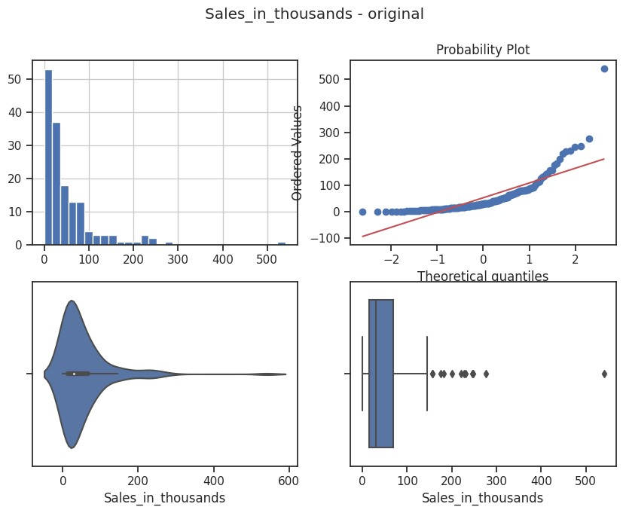
In [31]:
diagnostic_plots
(
data2
,

'Fuel_capacity'
,

'Fuel_capacity - original'
)

<ipython-input-29-1fe78d5d2ee2>:4: MatplotlibDeprecationWarning: Auto-removal of overlappi
ng axes is deprecated since 3.6 and will be removed two minor releases later; explicitly c all ax.remove() as needed. plt.subplot(2, 2, 1)
# Вычисление верхней и нижней границы
lower_boundary, upper_boundary = get_outlier_boundaries(data2, "Sales_in_thousands")
# Флаги для удаления выбросов
outliers_temp = np.where(data2["Sales_in_thousands"] > upper_boundary, True,
np.where(data2["Sales_in_thousands"] < lower_boundary, True, Fals
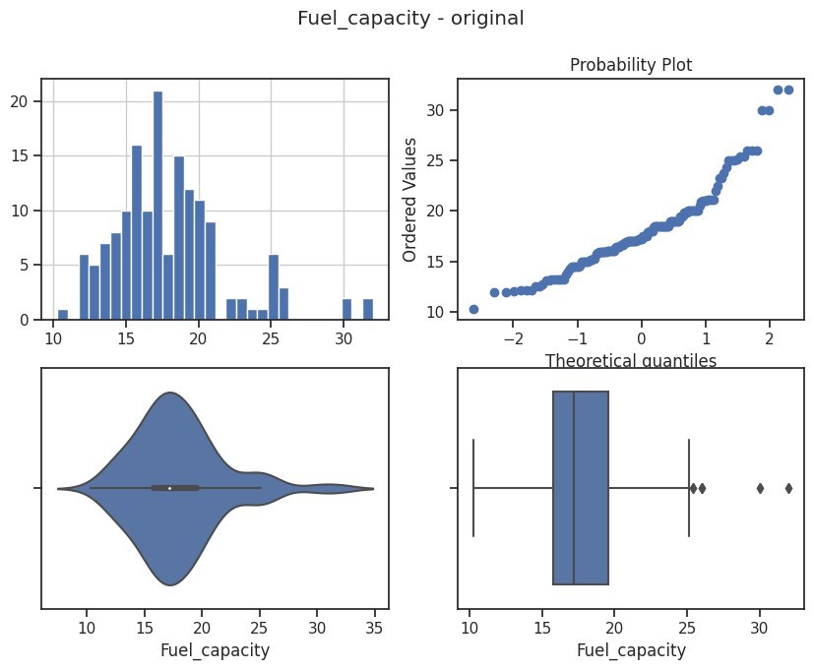
In [32]:
# Тип вычисления верхней и нижней границы выбросов from enum import Enum class OutlierBoundaryType(Enum):
SIGMA = 1
QUANTILE = 2
IRQ = 3
In [33]:
# Функция вычисления верхней и нижней границы выбросов def get_outlier_boundaries(df, col): lower_boundary = df[col].quantile(0.05) upper_boundary = df[col].quantile(0.95) return lower_boundary, upper_boundary

Удаление выбросов (number_of_reviews)
In [34]:
<ipython-input-29-1fe78d5d2ee2>:4: MatplotlibDeprecationWarning: Auto-removal of overlappi ng axes is deprecated since 3.6 and will be removed two minor releases later; explicitly c all ax.remove() as needed. plt.subplot(2, 2, 1)
# Удаление данных на основе флага
data_trimmed = data2.loc[~(outliers_temp), ]
title = 'Поле-{}, метод-{}, строк-{}'.format("Sales_in_thousands", "QUANTILE", data_trimme diagnostic_plots(data_trimmed, "Sales_in_thousands", title)
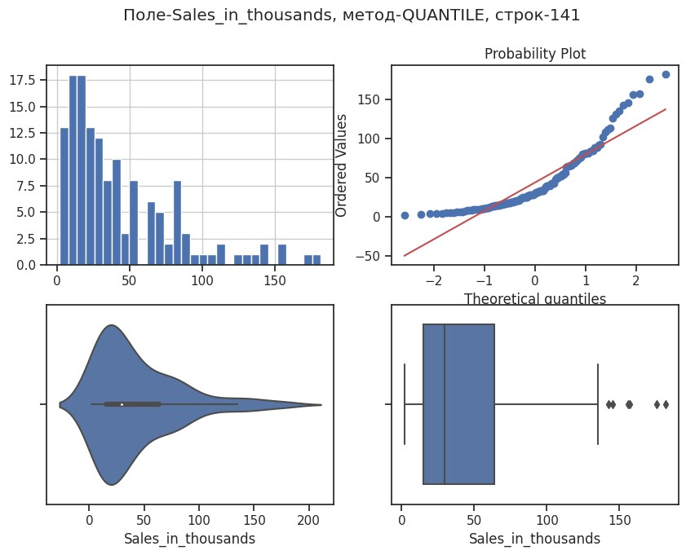

Замена выбросов
In [35]:
,
# Вычисление верхней и нижней границы
lower_boundary, upper_boundary = get_outlier_boundaries(data2, "Fuel_capacity")
# Изменение данных
data2["Fuel_capacity"] = np.where(data2["Fuel_capacity"] > upper_boundary, upper_boundary np.where(data2["Fuel_capacity"] < lower_boundary, lower_boundary, dat title = 'Поле-{}, метод-{}'.format("Fuel_capacity", "QUANTILE") diagnostic_plots(data2, "Fuel_capacity", title)
<ipython-input-29-1fe78d5d2ee2>:4: MatplotlibDeprecationWarning: Auto-removal of overlappi ng axes is deprecated since 3.6 and will be removed two minor releases later; explicitly c all ax.remove() as needed.
plt.subplot(2, 2, 1)

Обработка нестандартного признака
In [36]:
data2
.
dtypes

Manufacturer object Out[36]:
Model object
Sales_in_thousands float64
__year_resale_value float64
Vehicle_type object
Price_in_thousands float64
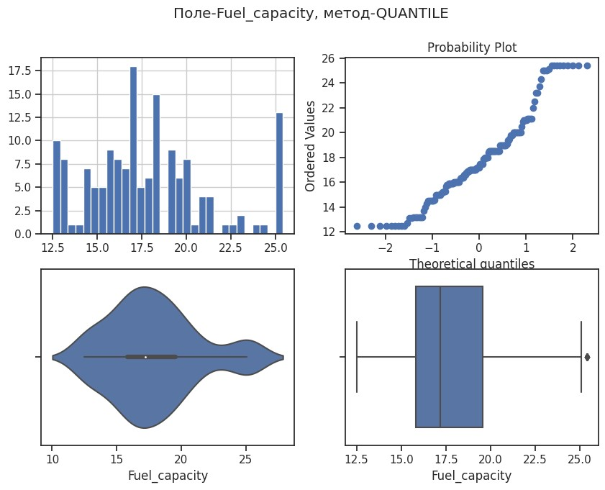
Engine_size float64
Horsepower float64
Wheelbase float64
Width float64
Length float64
Curb_weight float64
Fuel_capacity float64
Fuel_efficiency float64
Latest_Launch object Power_perf_factor float64 dtype: object
In [37]:
# Сконвертируем дату и время в нужный формат
data2["Latest_Launch_Date"] = data2.apply(lambda x: pd.to_datetime(x["Latest_Launch"], for
In [38]:
Out[38]: Model Vehicle_type
0 | Acura | Integra | 16.919 | 16.360 | Passenger | 21.50 | 1.8
1 | Acura | TL | 39.384 | 19.875 | Passenger | 28.40 | 3.2
2 | Acura | CL | 14.114 | 18.225 | Passenger | NaN | 3.2
3 | Acura | RL | 8.588 | 29.725 | Passenger | 42.00 | 3.5
4 | Audi | A4 | 20.397 | 22.255 | Passenger | 23.99 | 1.8
In [39]:
data2
.
dtypes

Manufacturer object
Out[39]:
Model object
Sales_in_thousands float64
__year_resale_value float64
Vehicle_type object
Price_in_thousands float64
Engine_size float64
Horsepower float64
Wheelbase float64
Width float64
Length float64
Manufacturer
Sales_in_thousands
__year_resale_value
Price_in_thousands
Engine_size
Hors
data2
.
head
(
5
)

Curb_weight float64
Fuel_capacity float64
Fuel_efficiency float64
Latest_Launch object
Power_perf_factor float64 Latest_Launch_Date datetime64[ns] dtype: object
In [40]:
# День
data2['Latest_Launch_Day'] = data2['Latest_Launch_Date'].dt.day
# Месяц
data2['Latest_Launch_Month'] = data2['Latest_Launch_Date'].dt.month
# Год
data2['Latest_Launch_Year'] = data2['Latest_Launch_Date'].dt.year

Отбор признаков Метод фильтрации (Корреляция признаков)
In [41]:
sns
.
heatmap
(
data
.
corr
()
,

annot
=
True
,

fmt
=
'.3f'
)

<Axes: > Out[41]:
In [42]:
# Формирование DataFrame с сильными корреляциями def make_corr_df(df): cr = data.corr() cr = cr.abs().unstack()
cr = cr.sort_values(ascending=False) cr = cr[cr >= 0.3] cr = cr[cr < 1]
cr = pd.DataFrame(cr).reset_index() cr.columns = ['f1', 'f2', 'corr'] return cr
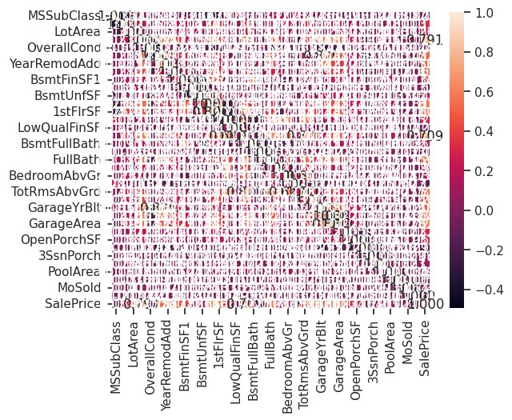
In [43]:
# Обнаружение групп коррелирующих признаков def corr_groups(cr): grouped_feature_list = [] correlated_groups = []
for feature in cr['f1'].unique(): if feature not in grouped_feature_list: # находим коррелирующие признаки correlated_block = cr[cr['f1'] == feature]
cur_dups = list(correlated_block['f2'].unique()) + [feature] grouped_feature_list = grouped_feature_list + cur_dups
correlated_groups.append(cur_dups)
return correlated_groups
In [44]:
# Группы коррелирующих признаков corr_groups(make_corr_df(data))
Out[44]: [['GarageArea',
'SalePrice',
'OverallQual',
'GarageYrBlt',
'YearBuilt',
'FullBath',
'GrLivArea',
'1stFlrSF',
'TotalBsmtSF',
'YearRemodAdd',
'MasVnrArea',
'TotRmsAbvGrd',
'Fireplaces',
'GarageCars'],
['GrLivArea',
'TotRmsAbvGrd',
'HalfBath',
'BedroomAbvGr',
'FullBath',
'SalePrice',
'MSSubClass',
'2ndFlrSF'],
['BsmtFullBath',
'TotalBsmtSF',
'BsmtUnfSF',
'1stFlrSF',
'SalePrice',
'BsmtFinSF1'],
['1stFlrSF',
'GrLivArea',
'TotalBsmtSF',
'MSSubClass',
'SalePrice',
'GarageArea',
'TotRmsAbvGrd',
'LotArea',
'LotFrontage'],
['YearBuilt', 'EnclosedPorch'],
['YearBuilt', 'GarageYrBlt', 'OverallCond'],
['GrLivArea', 'SalePrice', 'OverallQual', 'OpenPorchSF'],

['SalePrice', 'WoodDeckSF']] Метод из группы методов вложений
In [45]:
data3

=

pd
.
read_csv
(
"WineQT.csv"
,

sep
=
","
)

In [46]:
X3_ALL

=

data3
.
drop
([
'quality'
]
,

axis
=
1
)

In [47]:
# Разделим выборку на обучающую и тестовую
X3_train, X3_test, y3_train, y3_test = train_test_split(X3_ALL, data3['quality'], test_size=0.2, random_state=1)
In [48]:
# Используем L1-регуляризацию
e_lr1 = LogisticRegression(C=1000, solver='liblinear', penalty='l1', max_iter=500, random_ e_lr1.fit(X3_train, y3_train) # Коэффициенты регрессии e_lr1.coef_
array([[ 8.12685010e-01, 1.13666762e+01, 7.82623669e+00,
Out[48]: 2.73003859e-01, 2.20854445e+00, -8.14499398e-02,
-6.07359291e-02, -9.71364320e+00, 1.05928330e+01,
-3.02935401e+00, -3.49793957e+00, 4.48070237e-03],
[-1.70947991e-02, 3.42135554e+00, -1.21007833e-01,
8.32452278e-02, 3.20689559e+00, 1.03669460e-02, -1.25693925e-02, -5.18479271e+00, 2.46658035e+00,
9.88462824e-01, -2.04766665e-01, -4.73535890e-04],
[-1.50633685e-01, 1.93721323e+00, 1.12321685e+00,
1.01141678e-02, 1.55206374e+00, -1.74615115e-02,
1.48826890e-02, 5.10001726e+00, -2.81228295e-02,
-2.62509731e+00, -9.26899115e-01, 5.26799951e-05],
[ 1.90322225e-01, -1.79843954e+00, -2.04300613e+00,
-4.72955643e-02, 2.58455381e+00, 1.21352411e-02,
-7.83754176e-03, -2.99949432e+00, 9.79232831e-01,
8.78802257e-01, 2.38635326e-01, 1.63131072e-04],
[-2.89452663e-02, -3.07001091e+00, 1.47490514e+00,
7.64831115e-02, -1.76133253e+01, 2.58137752e-02, -2.04458316e-02, -3.51585085e+00, -1.28269840e+00,
2.73049298e+00, 8.81957513e-01, -5.47347256e-04],
[-5.95096357e-01, 3.04283371e+00, 3.41733495e+00,
-1.83182731e-01, -3.51167880e+01, -2.83696795e-02,
-2.51328328e-02, 7.93053290e+00, -9.85694602e+00,
3.86988223e+00, 1.26366792e+00, 6.15531404e-04]])
In [49]: # Все признаки являются "хорошими" from sklearn.feature_selection import SelectFromModel sel_e_lr1 = SelectFromModel(e_lr1) sel_e_lr1.fit(X3_train, y3_train) sel_e_lr1.get_support()
array([ True, True, True, True, True, True, True, True, True, Out[49]:
True, True, True])
# Признаки с флагом False д.б. исключены
In [50]:
e_lr2 = LinearSVC(C=0.01, penalty="l1", max_iter=2000, dual=False)
e_lr2.fit(X3_train, y3_train) # Коэффициенты регрессии e_lr2.coef_
array([[ 0.00000000e+00, 0.00000000e+00, 0.00000000e+00, Out[50]:
0.00000000e+00, 0.00000000e+00, 0.00000000e+00, -4.12130029e-03, 0.00000000e+00, 0.00000000e+00,
0.00000000e+00, -8.74167991e-02, 2.15055368e-05],
[-3.25687798e-02, 0.00000000e+00, 0.00000000e+00,
0.00000000e+00, 0.00000000e+00, 0.00000000e+00, -1.53909186e-03, 0.00000000e+00, 0.00000000e+00,
0.00000000e+00, -5.09548206e-02, -7.57658974e-05],
[ 5.37963884e-03, 0.00000000e+00, 0.00000000e+00,
0.00000000e+00, 0.00000000e+00, -1.01448829e-02,
9.74948422e-03, 0.00000000e+00, 2.68713702e-01,
0.00000000e+00, -1.39086322e-01, 6.67062423e-05],
[-3.23477532e-03, 0.00000000e+00, 0.00000000e+00,
-3.13809898e-03, 0.00000000e+00, 8.03447243e-03,
-6.31263148e-03, 0.00000000e+00, 0.00000000e+00,
0.00000000e+00, 0.00000000e+00, 1.50668477e-05],
[-3.14912831e-03, 0.00000000e+00, 0.00000000e+00,
0.00000000e+00, 0.00000000e+00, 3.10838096e-03, -4.09583482e-03, 0.00000000e+00, -2.53569087e-01,
0.00000000e+00, 3.23836792e-02, -8.18803137e-05],
[-3.58432219e-02, 0.00000000e+00, 0.00000000e+00,
0.00000000e+00, 0.00000000e+00, 0.00000000e+00, -3.69134838e-03, 0.00000000e+00, 0.00000000e+00,
0.00000000e+00, -4.94265352e-02, -5.74247806e-05]])
In [51]:
array([ True, False, False, True, False, True, True, False, True, Out[51]:
sel_e_lr2 = SelectFromModel(e_lr2) sel_e_lr2.fit(X3_train, y3_train) sel_e_lr2.get_support()
False, True, True])

